**PROJECT REPORT TEMPLATE**

**UNCOVERING THE GAMING INDUSTRY’S HIDDEN GEMS: A COMPREHENSIVE ANALYSIS OF VIDEO GAME SALES**

1. **INTRODUCTION:**

Video game sales analysis is the process of collecting and analyzing data about the sales of video games in order to understand market trends and consumer behavior. This type of analysis can be useful for a variety of purposes, including identifying the most popular games and genres, predicting future sales, and developing marketing strategies.Video game sales analysis typically involves collecting data from Kaggle sources. It was generated by a scrape of vgchartz.com. This data may include information about the number of units sold, the retail price, and the platforms on which the games are played. Once the data has been collected, it is typically analyzed using tableau. The results of the analysis can be used to identify trends and patterns in the market, and to make informed decisions about the development and marketing of video games.Video game sales analysis may be conducted by game developers, publishers, retailers, and other industry professionals. It is an important part of the video game industry, as it helps to understand the needs and preferences of consumers and to identify opportunities for growth and innovation. Analysing sales data from more than 16,500 games. This dataset contains a list of video games with sales greater than 100,000 copies. It was generated by a scrape of vgchartz.com.

1. **PROBLEM  DEFINITION & DESIGN THINKING:**

EMPATHY MAP:

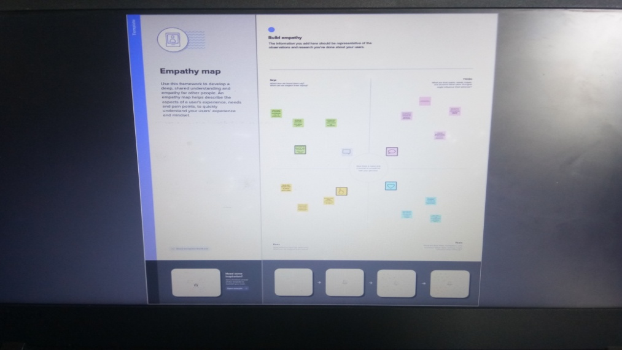

BRAINSTORMING & IDEATION MAP:



1. **RESULTS:**















1. **ADVANTAGES & DISADVANTAGES :**

**Education**

Studies have found that video games can improve learning. When video games have been used in the classroom, teachers see improved test scores. Games also allow students to learn and then apply what they have learned in a real-life situation. Medical and military training programs both use simulation-style games to teach tools and strategy.

**Life Skills**

Many video games teach kids how to delegate, work as a team, and prioritize. Internet-enabled games that let kids play with their real-life friends often require collaboration and division of tasks to beat the level.

**Improved Brain Function**

Video games have been shown to help us improve our ability to reason and solve problems. They help us make split-second decisions, process information more quickly, and multitask effectively. Games can also improve hand-eye coordination and boost auditory perception.

### ****Violence****

While every other study seems to draw opposite conclusions about the social effects of playing violent video games,  studies involving brain scans are concerning.

Simply put, children playing violent video games show decreased activity in areas of the brain dedicated to self-control and an increase in emotional arousal.

Even though the debate continues, be aware of how violent games affect your children. If you notice a problem, go with your gut.

Help your children choose games you feel are appropriate. Many console game ratings include detailed information about the contents of the game’s violence level, language, topics, etc.

### ****Addiction****

England’s National Health Service began treating video game addiction this year, after the [World Health Organization](http://www.who.int/features/qa/gaming-disorder/en/) listed “gaming disorder” in its International Classification of Disease.

What makes video games addictive? Playing releases dopamine into our systems, which gives us a feeling of pleasure and tells our brain to “do it again.”

As a matter of fact, video games are designed to be addictive. John Hopson, a games researcher at Microsoft Game Studios is also a doctor of behavioral and brain sciences who writes about game design.

In “Behavioral Game Design” he explained how game designers can control behavior by providing simple stimulus and rewards at strategic times and places.

Children with poor impulse control or who have a hard time fitting in are most vulnerable to game addiction. This may be because video games offer an easy way to fill the void created when real-world relationships are hard to form.

1. **APPLICATIONS:**

Data science is being used by gaming developers to study the behaviour of users and analyse it to make predictions and decisions. The new generation games not only analyse a player's behaviour, but also make use of artificial intelligence and machine learning techniques for better development. Game theory has been applied to a wide range of marketing decisions: negotiations/ bargaining, competitive behavior, innovation, pricing/bidding, market strategy, etc. Game theory is widely applied in the real world. Major areas of application include economics, diplomacy, and military strategy. Game theory can also be applied in fields such as psychology, biology, political science, computer science, sociology, and more.

1. **CONCLUSION:**

Video games are a form of media that is often associated with negative health consequences. However, when games are played in moderation and with mindfulness, they are a viable source of stress relief as well as a catalyst for mental health improvement and development of social skills. The video game industry encompasses the development, marketing, and monetization of video games. The industry encompasses dozens of job disciplines and thousands of jobs worldwide.

1. **FUTURE SCOPE:**

The future of gaming looks bright, with the emergence of new technologies such as virtual reality and the increased prevalence of mobile gaming. Virtual reality (VR) has the potential to revolutionize the gaming industry by immersing players in a fully interactive and realistic digital world. Different gaming studios offer different types of designations to game designers, like team leader, designing expert, designing managers etc. Once skilled enough, you can work as a freelancer too.